**Azure DevOps Assessment – Banking Application**

**Objective**

This document outlines the complete process for the Azure DevOps Assessment focused on building a basic structure for a Banking Application. The project includes breaking down work items, setting up a Git repository, and configuring a CI/CD pipeline.

**Part 1 – Work Item Breakdown**

Epics

1)User Management

Manage the lifecycle of users including registration, authentication, and password recovery.

2)Account Services

Enable users to create and manage bank accounts.

3)Fund Transfer

Support transferring money between accounts and external entities.

4)Transaction History

Provide a complete log of user transactions and filters for tracking.

5)Security & Compliance

Implement security measures and regulatory compliance (e.g., encryption, audit logs).

Features, User Stories, and Tasks

Epic: User Management

Feature: User Registration

US1: Register as a new user using email and password

US2: Admin approval for user registrations

Feature: User Authentication

US3: Login with email and password

US4: Logout securely

Feature: Password Reset

US5: Request password reset link

US6: Reset password using verification

Epic: Account Services

Feature: Account Creation

US7: Open a new bank account

Feature: View Account Details

US8: View account balance and type

Feature: Update Account Info

US9: Edit non-critical account details (e.g., contact info)

Epic: Fund Transfer

Feature: Internal Transfers

US10: Transfer funds between own accounts

Feature: External Transfers

US11: Transfer money to another user's account

US12: Transfer money to external bank accounts

Epic: Transaction History

Feature: View All Transactions

US13: View complete transaction history

Feature: Filter Transactions

US14: Filter transactions by date, amount, and type

Epic: Security & Compliance

Feature: Two-Factor Authentication

US15: Enable two-factor authentication at login

Feature: Audit Logging

US16: Log user activities for audit

Feature: Data Encryption

US17: Encrypt sensitive user data

**Part 2 – Azure DevOps Git Setup**

Create a new repository named banking-app in Azure DevOps Repos.

Clone the repository and add the following structure:

banking-app/

├── README.md

├── src/

│ └── app.py

└── .azure-pipelines.yml

Push the changes to the main branch.

**Part 3 – Configure CI/CD Pipeline**

Use the following YAML for your .azure-pipelines.yml file:

trigger:

- main

pool:

vmImage: 'ubuntu-latest'

steps:

- task: UsePythonVersion@0

inputs:

versionSpec: '3.x'

- script: python src/app.py

displayName: 'Run Banking Application Placeholder'

Part 4 – Submission Checklist

Submit the following:

Screenshot of Epics, Features, User Stories, and Tasks in Azure Boards

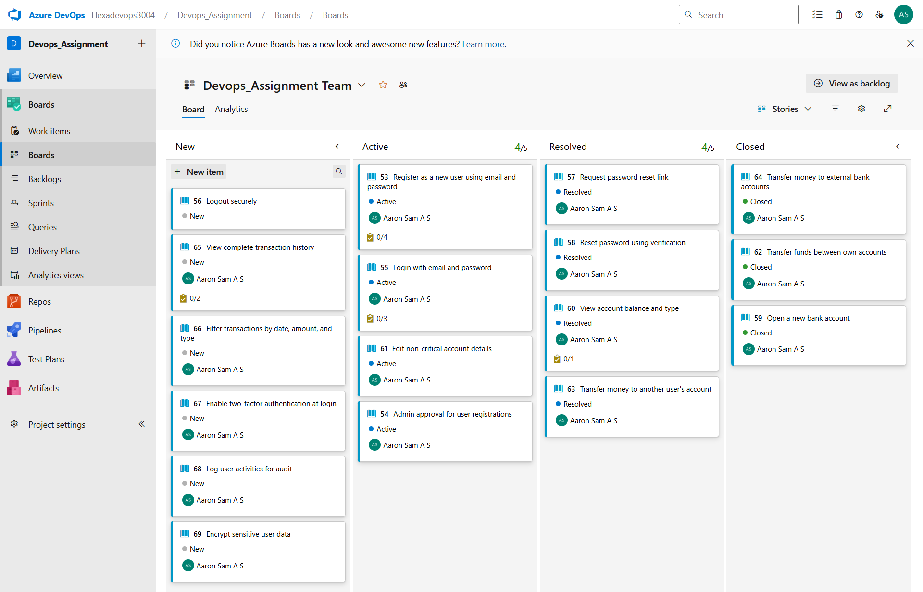

**Screenshot of Git Repository with project structure**

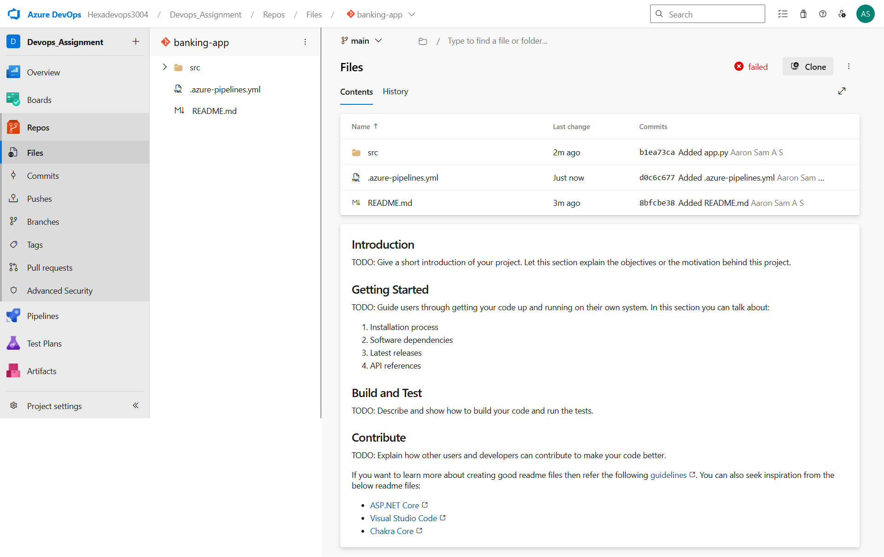

**Screenshot of successful CI/CD pipeline run**

